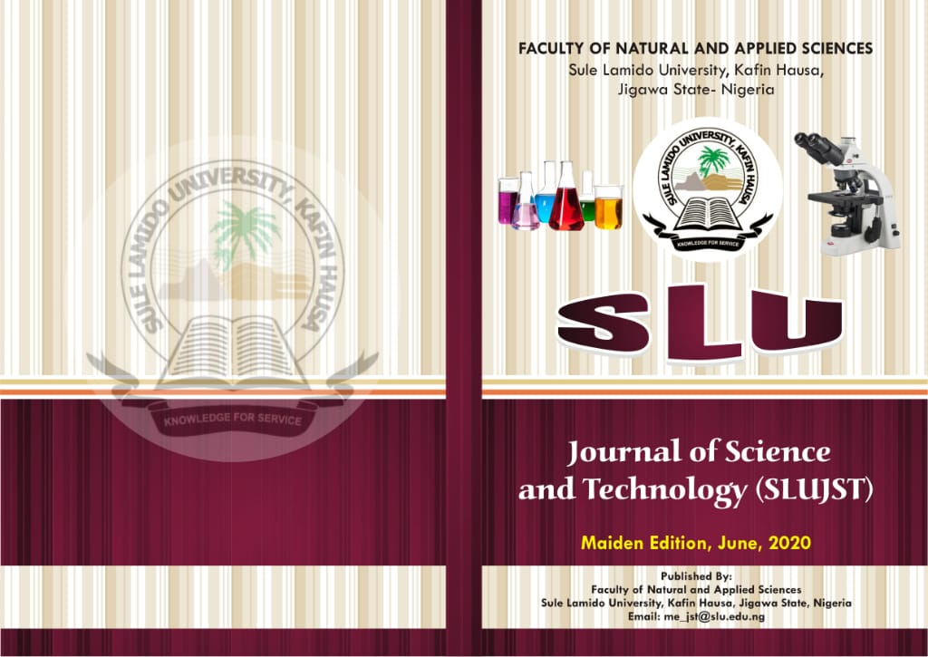

**Online: ISSN 2736-0903 Print ISSN: 2736-089X**

**Vol 3, No. 1&2, 2022 (June)**

**Volume 3, Issues 1&2, 2022**



**SLU Journal of Science and Technology (SLUJST)**

**Online: ISSN 2736-0903 Print ISSN: 2736-089X**

**Website:** [**www.slujst.com.ng**](http://www.slujst.com.ng)

**PUBLISHED BY:**

**Faculty of Natural and Applied Sciences**

**Sule Lamido University, P.M.B 048, Kafin Hausa**

**Jigawa State, Nigeria**

**Umar Ali (Ph.D).**

***Editor-in-Chief***

© Faculty of Natural and Applied Sciences, Sule Lamido University, P.M.B 048, Kafin Hausa, Jigawa State, Nigeria– 2022

*All right reserved. No part of this publication may be reproduced, stored in a retrieval system or transmitted in any form or by any means, electronic, mechanical, photocopying, recording or otherwise, without permission in writing from the copy right owner.*

**Online: ISSN 2736-0903**

**Print ISSN: 2736-089X**

**PUBLISHED BY:**

*Faculty of Natural and Applied Sciences*

*Sule Lamido University, Jigawa State, Nigeria*

**JOURNAL MANAGEMENT TEAM**

**EDITOR-IN-CHIEF**

**Dr. Umar Ali**

*Department of Chemistry*

*Faculty of Natural and Applied Sciences, Sule Lamido University*

*Mobile Phone: +2348063123112 and 08081259221*

Email: eic_jst@slu.edu.ng

**MANAGING EDITOR**

**Prof. Nasir Faruk**

*Department of Physics, Faculty of Natural and Applied Sciences*

*Sule Lamido University*

*Mobile Phone: +2348032428141*

Email: me_jst@slu.edu.ng

**ASSISTANT MANAGING EDITOR**

**Dr. Salisu Garba**

*Department of Computer Science, Faculty of Natural and Applied Sciences*

*Sule Lamido University*

*Mobile Phone: +2348034990732*

Email: ame_jst@slu.edu.ng

**PRODUCTION EDITOR**

**Prof. Rashid Husain**

Department of Maths and Computer Science, Sule Lamido University, Kafin Hausa

**Email:** [**pro_jst@slu.edu.ng**](mailto:pro_jst@slu.edu.ng)

**PRODUCTION MANAGER**

**Dr. Sani Durumin Iya**

*Department of Physics, Faculty of Natural and Applied Sciences*

*Sule Lamido University*

*Mobile: 08034656599*

**EDITORIAL SECRETARY**

**Dr. Shuaibu Yusuf**

Chemistry Department, Sule lamido University, Kafin hausa

**Email: sec_jst@slu.edu.ng**

**BUSINESS MANAGER**

**Mr. Abdullahi Mikailu**

Department of Physics, Sule Lamido University, Kafin Hausa

**Email:** [**bus_jst@slu.edu.ng**](mailto:bus_jst@slu.edu.ng)

**ASSISTANT PRODUCTION EDITOR**

**Dr. Muhammad Jamil Ibrahim**

Department of Maths and Computer Science, Sule Lamido University, Kafin Hausa

**WEB MANAGER**

**Mr. Marzuk Abdullahi**

Department of Maths and Computer Science, Sule Lamido University, Kafin Hausa

**Editorial Advisory Board Members**

Prof. Lawan Sani Taura, Sule Lamido University, Jigawa State Nigeria

Prof. Dalha Wada Taura, Bayero University, Kano, Nigeria

Prof R. G Jimoh, University of Ilorin, Ilorin, Nigeria

Prof. Lawan Danlarai Fagwalawa, KUST, Wudil, Nigeria

Prof. Lesley Smith. Hull University, UK

Prof. Chifu E. Ndikilar, Federal University Dutse, Nigeria.

Prof. Sunusi Muhammad, UDUS, Nigeria

Prof. Muhammad Bashir Ibrahim, Bayero University Kano, Nigeria

Prof Babawuro Usman, Kano University of Science and Technology, Wudil, Nigeria

Dr A. D. Usman, Ahmadu Bello University, Zaria, Nigeria

Prof. Abrar Ahmad Khan, Aligrah Muslim University, India

Prof. Ahmed Baita Garko, Federal University Dutse, Nigeria

Prof. Anene Moneke, UNN, Nigeria

Dr. Muhamad Zaky Bin Noh, University Tun Hussein Onn Malaysia

Dr Maitama Yusuf Abubakar, KUST Wudil, Kano Nigeria

Prof. A. H. Arzai, Bayero University, Kano, Nigeria

Prof. Fagade oba, University of Ibadan, Nigeria

Prof. Vincent Ebakwe. Federal University of Technology, Owerri, Nigeria

Prof. Ekuobase Osaretin Godspower. UNIBEN, Nigeria

Dr Abubakar Abdulkarim, ABU, Zaria

Dr. A.O Oloyede, University of Ilorin, Nigeria

Dr. Shafi'i Muhammad Abdulhamid, Federal University of Technology Minna, Nigeria.

Dr. Sanusi Alhaji Jibrin, Department of Statistics, KUST Wudil, Nigeria.

## Author Guidelines

**Preparation of the Manuscript**

Manuscript should be written in English Language and typed in 12 point font size using Times New Roman in double spacing on A4 paper. A margin of 25 mm should be left at the sides. The paper should not exceed twenty (20) pages, including figures and tables. The manuscript should be organised under the following headings:

**Title Page**

The title page should contain only the title of the article, authors’ contact details such as names, institutional affiliations, corresponding author’s email address and phone number. This should be uploaded as a supplementary document on the Author’s portal. Please note that the article title should not exceed fifteen (15) words.

**Abstract Page**

Page 1 of the manuscript should contain the title of the article, the abstract, five or six keywords, and may include the Introduction Section, etc. However, it must NOT contain name(s), and address(es) of author(s), and e-mail addresses and telephone number of the corresponding author. These information will be supplied on the online submission platform in addition to the uploaded title page above. The abstract should not normally exceed 250 words in 12 point font size.

**Keywords**   
Five or six relevant keywords should be provided on the title page.

**Symbols, Abbreviations and Units**

Symbols and abbreviations should be defined where first mentioned. If the symbols are many, a “Notation” defining the symbols must be included between the abstract and Introduction. SI units should be used.

**Introduction**   
This should include the background to the study, a brief review of literature and clearly-stated objectives.

**Theoretical Analysis**

* The mathematical principles or theories used should be included as appropriate.
* Materials and Methods/Methodology/Experimental Procedure
* This section should include apparatus and equipment setup, work materials, design, experimental methods, as applicable.
* Results and Discussion: Results could be presented in descriptive, tabular or graphical form. Information presented in tables should not be repeated as figures. Discussion should be focused on the interpretation of experimental findings.

**Conclusion**   
The conclusion should be a brief summary of findings. It should clearly state the contributions, relevance of the findings and recommendations, as appropriate.

**References**   
The APA system (alphabetical listing) of referencing should be used in the body of the manuscript while only essential references must be cited and listed. Examples of citing references include: Jimoh (2012) or (Jimoh, 2012) as appropriate; Faruk and Bajeh (2002) or (Nasir and Bajeh, 2002) as appropriate; Tella et al (2006) or (Tella et al, 2006) as appropriate. Examples of listing references are as follows:

**For Journal Articles**

Castles, F. G., Curtin, J. C., & Vowles, J. (2006). Public policy in Australia and New Zealand: The new global context. Australian Journal of Political Science, 41(2), 131–143.

Gelkopf, M., Ryan, P., Cotton, S., & Berger, R. (2008). The impact of “training the trainers” for helping tsunami-survivor children on Sri Lankan disaster volunteer workers. *International Journal of Stress Management,* 15(2), 117–135. https://doi.org/10.1037/1072-5245.15.2.117

**For a Book**

Okuda, M., Okuda, D, (1993). Star trek Chronology: The History of the Future. New York: Published by Pocket Books. URL i.e. publisher’s web address

**For Book Article or Chapter**

James, N.E. (1988). Two sides of paradise: the Eden myth according to Kirk and Spock. In Spectrum of the Fantastic Donald Palumbo (ed.) 219-223. Westport, C.T.: Published by Greenwood. URL

**For Edited Conference Proceeding**

Segun I. Popoola, Aderemi A. Atayero, Charles Ndujiuba, Francis E. Idachaba, Faruk. N, Carlos T. Calafate (2017). Calibrating the Standard Path Loss Model for Urban Environments using Field Measurements and Geospatial Data., The 2017 International Conference of Wireless Networks, London, U.K., 5-7 July, pp513-518, 2017.

**CALL FOR PAPERS** (SLUJST receives submissions all year round)

Dear Colleague,

It is our pleasure to invite you to submit your research papers to the SLU Journal of Science and Technology (SLUJST). SLUJST is an open access, peer reviewed and refereed international journal published by the faculty of Natural and Applied Sciences, Sule Lamido University, Kafin Hausa, Jigawa State, Nigeria. The Journal published twice annually in (June and December). The main objective of SLUJST is to provide an intellectual platform for the exchange of the latest research in science and Technology. SLUJST aims to promote interdisciplinary studies in Science and Technology and become the leading journal in Science and Technology. It now invites submissions for its forthcoming Volume 5 issues 1&2 (December) 2022. The journal is published in both print and online versions. The journal receives submission bordering on but not limited to the following areas:

* **Chemistry**
* **Earth and Atmospheric Sciences**
* **Physics**
* **Biology**
* **Agriculture**
* **Biophysics and Biochemistry**
* **Botany and Environmental Science**
* **Zoology**
* **Computer Science and Mathematics**
* **Materials Science**
* **Mechanics**
* **Statistics and Software Engineering**
* **Information Technology**

**Manuscript Submission**

Manuscript submissions are received through the online submission platform: <https://www.slujst.com.ng/index.php/jst/about/submissions> new authors are required to register on (if new to the platform) or log onto the platform before making their submission.See the sample paper format and author’s guide for manuscript preparation: Template for the Journal can also be downloaded on the website under the downloads. Please refer to our information pack for any further help access/using the journal portal.

Submissions must be original, not yet published and not submitted to or under review by any journal or publication outlet. All Manuscripts are double-blind peer-reviewed and if found suitable, published in the next available issue and according to the subject matter as **research paper**, **Review paper** or **technical note**. The evaluation of manuscripts will be based on:

**Underlying methodological soundness and rigor, Innovation of the work, the significance of the results and the quality of the reporting**

**Processing and Publication Charges**

A processing fee of N4, 000.00 should be paid while sending the manuscript and a publication charge of N10, 000.00 shall be charged after acceptance. All payment should be made to the following account:

Account Name: **ALI UMAR**

Name of Bank: **GT Bank**

Account Number: **0045629566**

A scanned copy of the teller should be uploaded as a supplementary file along with the manuscript in the author’s portal and/or sent electronically as an attachment to our e-mail address: **me_jst@slu.edu.ng** and **bus_jst@slu.edu.ng**. To encourage foreign authors, the processing fee is waived for any submission which does not have any Nigerian author.

**Indexing**

SLUJST is currently indexed in [Google Scholar](https://ijipc.com.ng/index.php/ijipc), Sule Lamido University Libraries,  [ResearchGate](https://ijipc.com.ng/index.php/ijipc), [Journals for free](https://ijipc.com.ng/index.php/ijipc) and [ACADEMIA](https://ijipc.com.ng/index.php/ijipc)

**Suggested Reviewers**

A list of, at least, three suggested reviewers should be provided with their current institutional affiliations as well as email addresses. However, please note that the Managing Editor reserves the right to determine the appropriate reviewers to review your manuscript. This request is simply to populate our database of reviewers in diverse fields.

**Submission Checklist**   
The following list will be useful during the final checking of your article prior to sending it to the journal for review. Please ensure that the following items are present:

* The title page contains only: Title of the manuscript, Authors’ names, affiliations, and contact details of the corresponding author.
* Ensure that the abstract page DOES NOT contain the authors’ details and contacts such as names, postal address, email address, and phone number.

**Further considerations**   
A list of three suggested reviewers and their email addresses has been provided. Manuscript has been 'spell-checked' and 'grammar-checked' References are in the correct format for this journal. All references mentioned in the Reference list are cited in the text, and vice versa

**Complimentary Journal Copies**

Authors can always download their published papers from our website at <https://www.slujst.com.ng>, However, corresponding author will received a print version of the journal. Extra copies shall attract a total sum of two thousand Five hundred Naira (N2,500:00) per copy.

**Review and Publication Process**  
A full double-blind refereeing process is used that comprises of the following steps.

* Paper is sent to 3 reviewers for review. The reviewers' recommendations determine whether a paper will be accepted / accepted subject to change / subject to resubmission with significant changes / rejected.
* For papers which require changes, the same reviewers will be used to ensure that the quality of the revised paper is acceptable.
* If the paper is accepted by the reviewers, author (s) will be notified to pay the author fee.
* Acceptance letter will be provided after the payment has been made.
* Author/Corresponding Author will be notified about the possible date of publication (both online and print).
* One hard copy of the published journal (Print) for each article will be sent to the author/corresponding author. The review process takes maximum 3 months.

**Copyright**  
Copyrights for articles published in SLUJST are retained by the authors, with first publication rights granted to the journal. The journal/publisher is not responsible for subsequent uses of the work. It is the author's responsibility to bring an infringement action if so desired by the author.

# Journal Office Contacts Addres

Faculty of Natural and Applied Sciences

Sule Lamido University

P.M.B 048, Kafin Hausa,

Jigawa State, Nigeria

### Principal Contact

**Prof. Nasir Faruk-*Managing Editor, SLUJST***

*Department of Physics, Sule Lamido University*

*Phone +234 8032428141; Email:  me_jst@slu.edu.ng*

**Support Contact**

**Dr. Salisu Garba- Assistant Managing Editor**

*Department of Computer Science, Faculty of Natural and Applied Sciences, Sule Lamido University*

*Mobile Phone: +2348034990732;* Email: ame_jst@slu.edu.ng

**EDITORIAL PREFACE**

I would like to welcome you to the Vol 3 issues 1&2 of the SLU Journal of Science and Technology, a peer-reviewed and broad-scope Journal that aims at bridging the gap between Science and Technology, and addresses both academics and practicing professionals. The Journal is designed to advance scientific knowledge and promote innovations that are focused in solving some of our problems.

Definitely, there are a number of Journals covering the above-mentioned areas. However, this Journal will be unique in that it encourages authors to submit works addressing key primal in scientific and engineering issues. In addition, the Journal is one of the few in Nigeria with standard and functional online editorial management system that gives authors an opportunity to view through their dashboard the review processes from submission up to the publishing stage of their Articles.

This issue of the Journal includes Fifteen (15) papers with high level of originality. They determine the face of the Journal and set the stage of subsequent issues that will publish mostly research papers: experimental, computational and reviews in the field of Science and Technology.

Finally, I would like to thank many people who created the opportunity for the Journal to be born and who made it happen. The list includes all current Editorial board members and Editorial advisory board members. In particular my thanks to Prof. Nasir Faruk (Managing Editor) for his tireless efforts in making the Journal a reality, Dr Salisu Garba (Assistant Managing Editor) and Dr. Sani Durumin Iya (Production Manager) for their unwavering help.

**Umar Ali, Ph.D.**

***Editor-in-Chief, SLUJST***

***Sule Lamido University, Kafin Hausa, Jigawa State, Nigeria***

**TABLE OF CONTENTS**

**Journal Management Team**

**Editorial Board IV**

**Auditor Guidelines VII**

**Call for Papers XI**

**Editorial Preface XIII**

**Table of Contents XIV**

**Impact of processing (toasting and fermentation) on the proximate, anti-nutrient and mineral composition of sickle pod (Senna obtusifolia) seeds.**

*Muhammad Abdulkadir, Danladi Amadu Ameh, Humphrey Chuks Nzelibe, Shehu Muhammad Hassan and Aliyu Mansir. 1-15*

**Proximate and Elemental Analysis of Dried Watermelon (citrullus lanatus) Seeds.**

*Suwaibatu Mamman, Ogbe Suleiman Musa, Abubakar Chadi Sadiq, Usman Saidu, and Obaje Daniel Opaluwa 16-22*

**Biochemical and PCR-based identification of Hydrocarbonoclastic Bacteria isolated from spent engine oil polluted soil.**

*Adeleye, A. O., Yerima, M. B. Nkereuwem, M. E. Onasanya, G. O., Onokebhagbe, V.O., Bate, G.B. and Raji, M. 23-34*

**Improved Handover Performance with Quality of service support using mobile IPV6 for Real-Time Applications.**

*Aliyu Aminu Abdulhadi and Abubakar Rufa’i Garba 35-41*

**Multidrug Resistance (MDR), Extensive Drug Resistance (XDR), and Pan Drug Resistance (PDR) Klebsiella Pneumoniae From Clinical Samples.**

*Nazeef Idris Usman, Nana Maryam Abdulwahab, Maryam Jumoke Sulaiman and Sa’adatu Abdullahi 42-50*

**Simulative analysis of Copper Indium Gallium Selinide (CIGS) Thin Film Solar Cell.**

*Muhammad Garba Wakili, Yahaya Ado Sumaila, Saddiq Abubakar Dalhatu, Hauwa Muhammad Mari and Abubakar Isah 51-56*

**Phytochemical, Proximate Analysis, and Antibacterial Activity of Cucumis sativus On Hypervirulent Klebsiella pneumonia.**

*Nazeef Idris Usman and Kobbe Amina Isa 57-63*

**Self-Sufficiency of Rice in Sierra Leone: A Review.**

*Andrew Borboh Sannoh, Abdulazeez Hudu Wudil, Azhar Abbas, Bashiru Mansaray, Dossa Lucres Imelda Ke-Tindagbeme 64-76*

**Development and Validation of a Stability-Indicating HPLC Method for the Estimation of Artesunate and some known Degradants using Force Degradation Studies.**

*Kazeem, A. Basheeru, Hussein K. Okoro., and Liyansan Segun Michael 77-88*

**Web-Based RFID Patient Identification System: A Case Study of UNILORIN Clinic**

*T. C. Adeniran, R. O. Odebiyi, L. A. Olawoyin, Nasir Faruk, Q. R. Adebowale, Salisu Garba 89-100*

**Evaluation of Physicochemical Parameters of Unbranded Palm Oil Samples Purchased from Important Markets in Lagos, Nigeria.**

*Liyansan, Segun Michael, Fatunsin, Oluwatoyin Tirenioluwa, Olayinka, Kehinde Ololade 101-112*

**Obesity Level Classification Based on Decision Tree and Naïve Bayes Classifiers.**

*Salisu Garba, Marzuk Abdullahi, Umar Abdullahi Umar and Nura Tijjani Wurnor 113-121*

**Comparative Analysis of the Drain Current in a 7nm and 14nm Fully Depleted Silicon-On-Insulator (SOI) MOSFET.**

*Sulaiman Muhammad Gana, Garba Shehu Musa Galadanci, Tijjani Hassan Darma, Abdurrazak Tijjani 122-130*

**Investigation of the Relationship between Land Surface Temperature and Radioactivity in Shira Hills, Bauchi State, Nigeria.**

*Salisu Tata, Bello Yusuf Idi, Dauda Abubakar, Sadiq Abubakar Dalhatu, Mohammed Auwal Adamu 131-138*

**Microcontroller-Based Carbon Monoxide Detector.**

*Abdulwaheed Musa 139-148*